**WEEK 12 - PERIOD 34**

**THEME 4: THE PAST**

**- LESSON 2 ( CONT) (Hướng dẫn HS tự học)**

***I. HƯỚNG DẪN HS TỰ TÌM HIỂU BÀI HỌC***

- HS mở STUDENT’S BOOK/ Pages 36, 37

- Đọc trước nội dung câu hỏi của bài.

***II. NỘI DUNG BÀI HỌC***

- Mở video clip hướng dẫn nghe kèm theo trên K12 để nghe và viết câu trả lời vào trong sách.

- Sau khi làm xong, các em nghe lại một lần nữa và kiểm tra đáp án.

**- Đối với các em nhận bài về nhà học, không nghe máy được, các em có thể đọc phần in nghiêng phía dưới để làm phần Listening.**

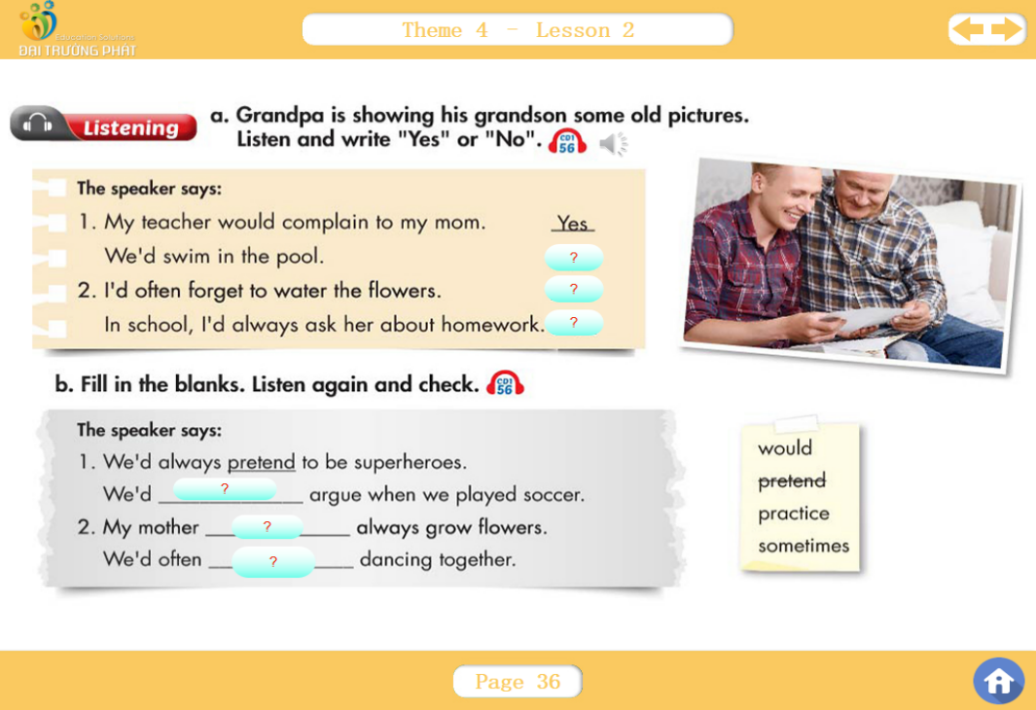

**🖭 Nội dung bài nghe:**

***Track 56***

***1.******Jimmy:*** *What's that, Grandpa?*

***Grandpa:*** *That's my kindergarten. I'd always cry on the way to school. I'd sometimes be late and my teacher would complain to my mom.*

***Jimmy:*** *Oh, I'm never late for school.*

***Jimmy:*** *Who's that?*

***Grandpa:*** *That's me and my best friends. We'd always pretend to be superheroes.*

***Jimmy:*** *I bet that was fun.*

***Grandpa:*** *We'd sometimes argue when we played soccer, though.*

***Jimmy:*** *That looks great! Where's that?*

***Grandpa:*** *It's my favorite beach. For summer vacation, my father would always take us there and we'd swim in the sea. He'd sometimes carry me on his back.*

***2.******Grandpa:*** *Look! This is great, isn't it?*

***Jimmy:*** *Yes, there are so many flowers! Where was that?*

*Grandpa: It was our garden. My mother would always grow flowers. I'd sometimes forget to water them and my father would get angry.*

***Jimmy:*** *Did you grow vegetables, too?*

***Grandpa:*** *Yes, we did. We'd often grow potatoes and carrots.*

***Jimmy:*** *Cool.*

***Jimmy:*** *Who's this?*

*Grandpa: That's your grandma. We'd often practice dancing together. In school, I'd always ask her about homework so I could talk to her more.*

***Jimmy:*** *That's sweet, Grandpa.*

***Jimmy:*** *Grandpa?*

***Jimmy:*** *Oh, never mind.*

***Narrator:*** *Now listen again and check.*

|  |  |  |
| --- | --- | --- |
| **KEY:** | **Listening a.**  1.Yes  No  2. No  Yes | **Listening b.**  1. pretend  sometimes  2. would  practice |

***III. LUYỆN TẬP***

- HS xem phần Useful Language

- HS tự luyện tập nói nói lại các câu.

- Thay thế các từ màu xanh theo ý mình và thực hành các câu hội thoại.

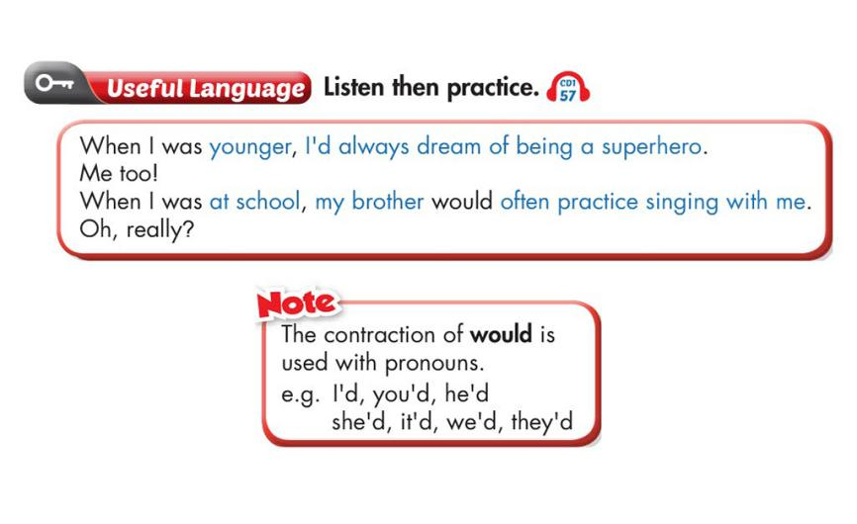

- HS mở sách trang 37, xem phần Practice.

- Luyện tập bài hội thoại. Thay thế các từ màu xanh bằng các từ trong ô bên phải.

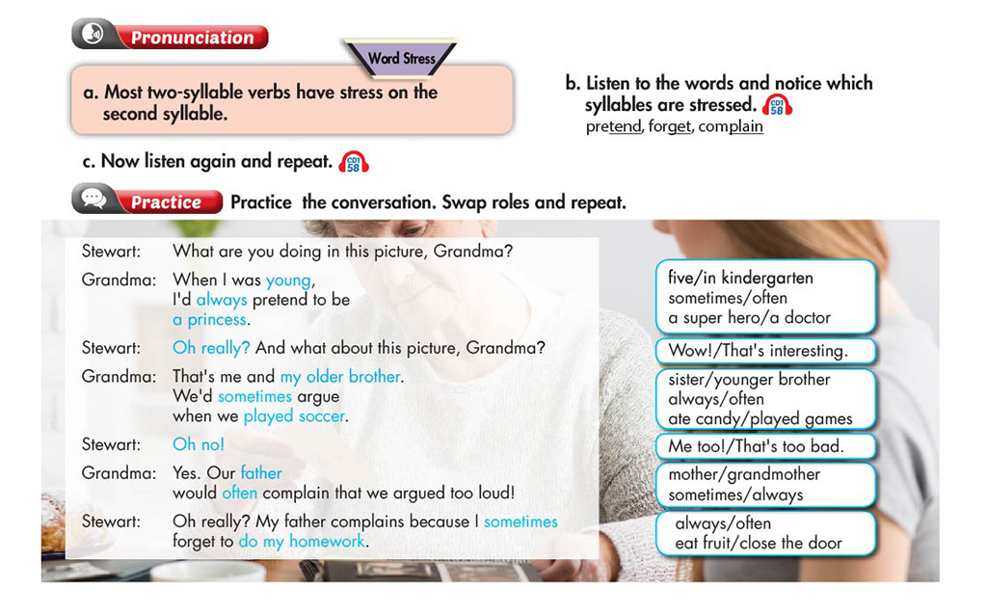

***IV. DẶN DÒ***

- Làm bài tập WORKBOOK /Pages 34, 35

- Làm xong bài tập các em chụp lại và nộp cho tổ trưởng báo cáo.

**WEEK 12 - PERIOD 35**

**EXERCISES (Hướng dẫn HS tự học)**

1. ***HƯỚNG DẪN***

- Các em ôn lại phần lí thuyết (từ vựng, ngữ pháp) trong Theme 4 (Lesson 1,2)

- Làm các bài luyện tập.

- Gửi bài cho tổ trưởng để báo cáo.

1. ***NỘI DUNG GHI BÀI***
2. THÌ QUÁ KHỨ HOÀN THÀNH: (PAST PERFECT TENSE)

🡪 Diễn tả hành động xảy ra trước hành động khác trong quá khứ

(+) S + had + V3/ed +…

(-) S + had not + V3/ed +…..

(?) Had + S + V3/ed…?

1. S + would + trạng từ tần suất + V1…

🡪 Chỉ hành động thường lặp lại trong qúa khứ

|  |
| --- |
| S + WOULD + always + V1  usually  often  sometimes |
| = S + always /usually /… + V2/_ed |
| = S + used to + V1 |

1. Các động từ cần chú ý

* pretend + to v1: giả bộ
* forget + to v1: quên
* complain + to + somebody: phàn nàn với (ai đó)

complain + about + something: phàn nàn về (việc gì đó)

* argue + about + something: tranh cãi về (việc gì đó)

argue + with + somebody: tranh cãi với (ai đó)

* practice + V-ing: luyện tập
* dream + of + (V-ing/N): mơ ước

1. ***LUYỆN TẬP***

***EXERCISE 1: Multiple Choice***

1. When I was younger, I’d often _________ to be a princess.

A. argue B. practice C. pretend D. forget

1. He’d _________ home before it rained.

A. go B. gone C. went D. goes

1. Her teacher would sometimes complain to her ______ her coming late.

A. to B. about C. with D. on

1. My mother had been a teacher before I _______ born.

A. is B. am C. were D. was

1. I’d _______ my homework before I ate lunch.

A. does B. did C. done D. do

1. When we were younger, we’d always pretend __________ doctors.

A. be B. being C. are D. to be

1. When I was a child, my grandma would often _____ me bedtime stories.

A. argue B. tell C. pretend D. practice

1. My father _____ always take me to a music club on the weekends.

A. does B. will C. would D. had

1. When I was six, I’d sometimes forget ______ my homework.

A. do B. to be done C. to do D. done

1. You’d _______ soda before you played soccer.

A. drink B. drunk C. drank D. drinks

1. Paul had _____ a sandwich before he went to school yesterday.

A. makes B. made C. make D. making

1. When they were at high school, they’d often practice ______ badminton.

A. playing B. plays C. played D. play

1. My sister and I would often ______ about toys.

A. go B. practice C. argue D.do

1. He’d ________ the guitar for 10 years before he taught me.

A. play B. playing C. played D. plays

1. I’d _______ lunch before I did exercise.

A. eat B. ate C. eating D. eaten

1. When I came home, my mother would always complain ______ my bad marks.
2. to B. with C. about D. on

***EXERCISE 2: Rewrite the sentences***

1. After they had gone home, it rained.

Before _________________________________________________.

1. He went to school after he’d made a cake.

Before _________________________________________________.

1. After she had drunk soda, she played tennis.

Before _________________________________________________.

1. We would often practice playing badminton when we were younger.

We used _________________________________________________.

1. He used to forget to do my homework.

He’d sometimes _________________________________________________.

|  |
| --- |
| **KEY:** |
| ***EXERCISE 1: Multiple Choice***  1. C 2. B 3.B 4. D 5. C 6. D 7. B 8. C  9. C 10. C 11. B 12. A 13. C 14. C 15. D 16. C |
| ***EXERCISE 2: Rewrite the sentences***   1. Before it rained, they had gone home 2. Before he went to school, he’d made a cake. 3. Before she played tennis, she had drunk soda. 4. We used to practice playing badminton when we were younger. 5. He’d sometimes forget to do my homework. |

1. ***DẶN DÒ***

- Các em ôn tập và làm bài tập đầy đủ.

- Nộp bài để báo cáo.

**WEEK 12 - PERIOD 36**

**THEME 4: THE PAST**

**- LESSON 4**

1. **New words**
2. castle (n) lâu đài
3. moat (n) hào nước
4. stone (n) đá
5. wood (n) gỗ

wooden (a) làm từ gỗ

1. brick (n) gạch
2. hill (n) đồi
3. dungeon (n) ngục tối
4. call (v) gọi là
5. citadel (n) thành lũy
6. safe (a) an toàn

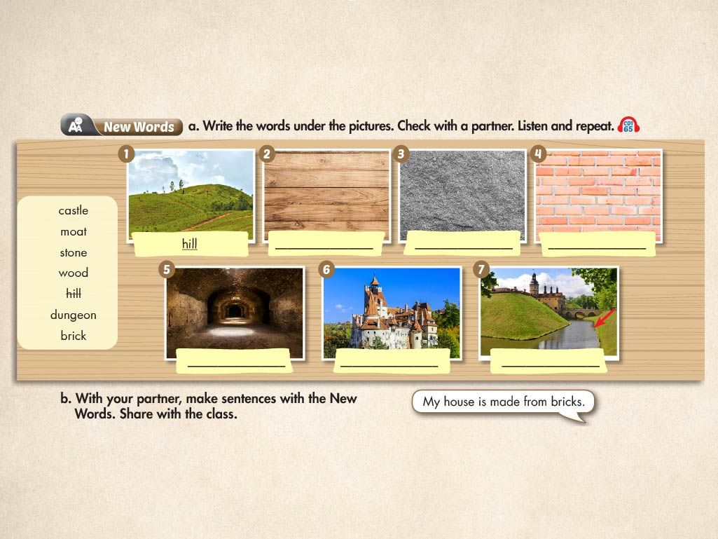

|  |  |
| --- | --- |
| **KEY:** | **New Words a.**  1. hill  2. wood  3. stone  4. brick  5. dungeon  6. castle  7. moat |

1. **Grammar**

**\* Passive Voice in the Past Simple Tense *(Thể bị động ở thì quá khứ đơn)***

**S + V-ed/2 + O + …**

**S’ + was/were + V-ed/3 + nơi chốn + by … + thời gian**

Ex1: They built Leads Castle in the 12th century.

🡪 Leads Castle was built in the 12th century.

Ex2: The workers made the walls from strong bricks.

🡪 The walls were made from strong bricks by the workers.

1. **Reading**

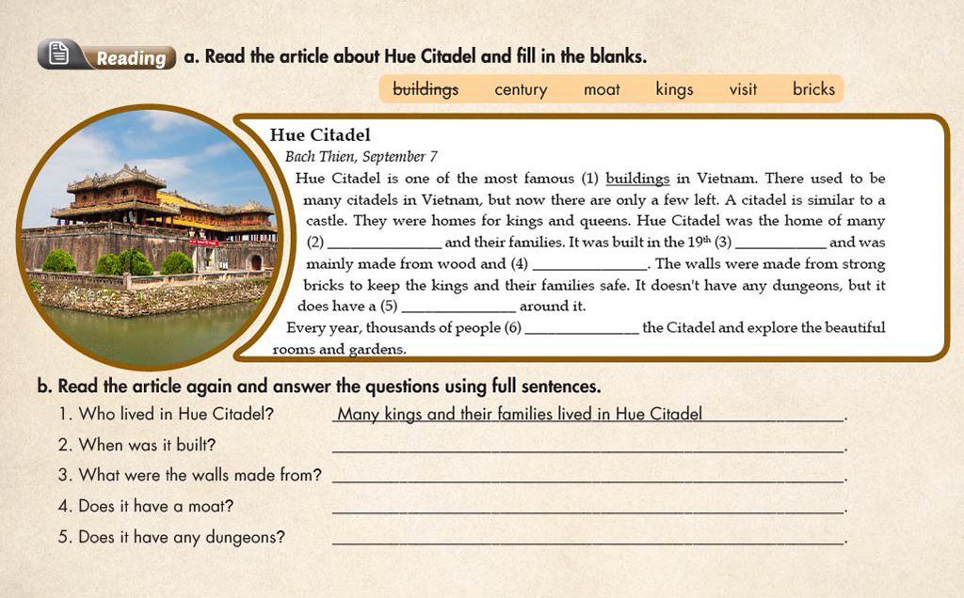

|  |  |
| --- | --- |
| **KEY:** | |
| **Reading a.** | 1. buildings  2. kings  3. century  4. brick  5. moat  6. visit |
| **Reading b.** | 1. Many kings and their families lived in Hue Citadel.  2. It was built in the 19th century.  3. The walls were built from strong bricks.  4. Yes, it does.  5. No, it doesn't. |

1. **Homework**

- Learn new words and structure by heart.

- Do the exercise.